

Information about the

Survivor Experiences Service

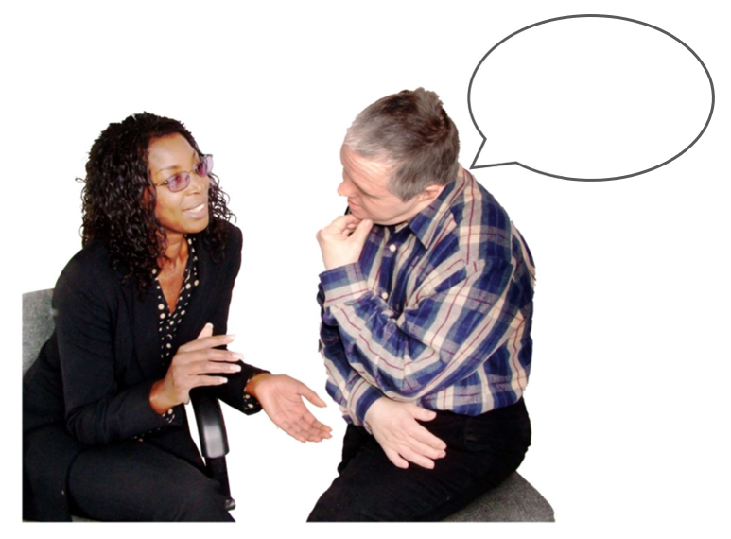

Updated: March 2025

# Before you start



This document talks about abuse.

This information may upset some people when they are reading it.

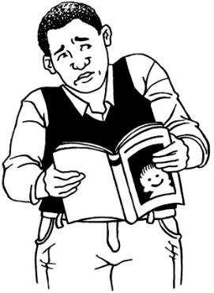

This information is not meant to scare anyone.

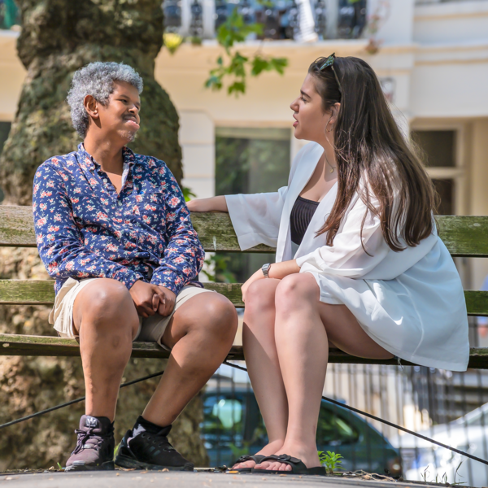If you are upset after reading this document you can talk to your:

whānau / family

friends.

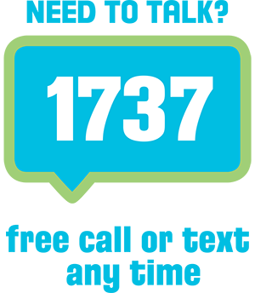You can also contact Need to Talk by:

calling 1737

texting 1737



It does not cost any money to call / text 1737.

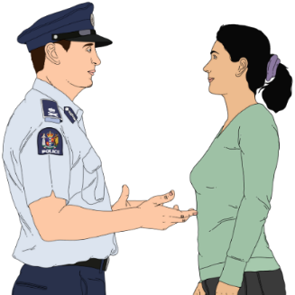

If you do not feel safe call the police on **111.**

# What is this document about?

This Easy Read document is about the **Survivor Experiences Service**.

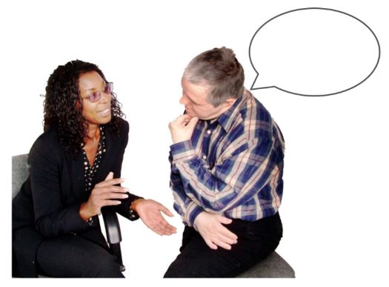The **Survivor Experiences Service** is for:

people who experienced **abuse** when they were **in care**

whānau / family of **survivors**

close supporters of **survivors**.

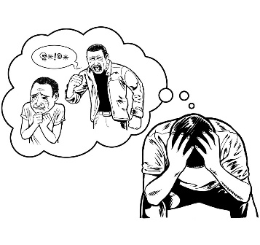

**Survivors** are people who experienced abuse when they were in care.

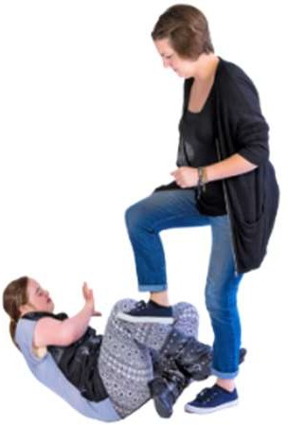**Abuse** can be:

**physical** – hurting your body by doing things like:

* kicking you
* hitting you

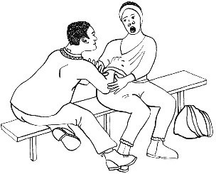**sexual** – doing sexual things that you do not want like:

* touching your body
* 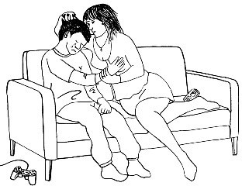touching your private parts
* kissing you
* making you have sex – this is called rape.

**Abuse** can also be:

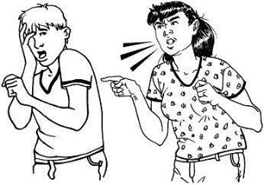**emotional** – doing things like:

* yelling
* saying things to you that are not nice

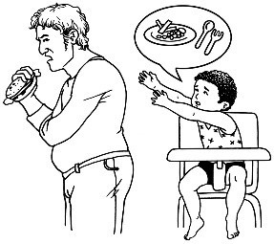**neglect** – not giving you:

* the things you need
* the care you need.



Being **in care** means the Government or a **faith-based institution** was in charge of looking after you.



**Faith-based institutions** are run by religious groups like churches.

****In this Easy Read document when we say **the service** we mean the **Survivor Experiences Service**.

# The Survivor Experiences Service

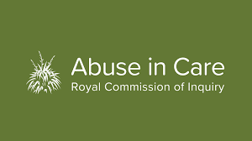

New Zealand had a **Royal Commission of Inquiry into Abuse in Care**.



The **Royal Commission of Inquiry into Abuse in Care** found out information about how people were hurt in care.

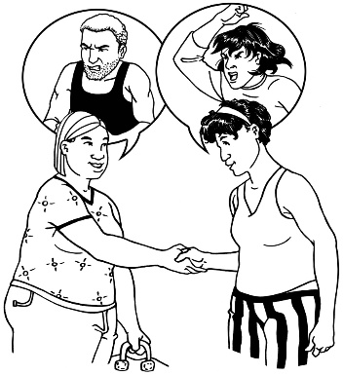

The Royal Commission said that survivors need to be able to:

share / talk abouttheir experiences

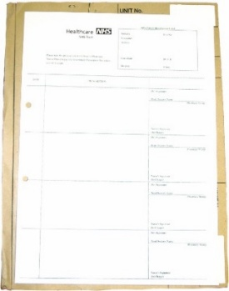easily get their **records** from their time in care

have support to understand their records.

**Records** are written information about when you were in care.

The Survivor Experiences Service was started to support people to do these things.

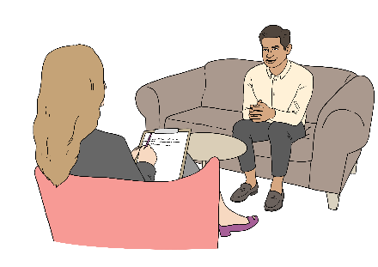

The Survivor Experiences Service has 2 services called the:

****sharing experiences service

records support service.

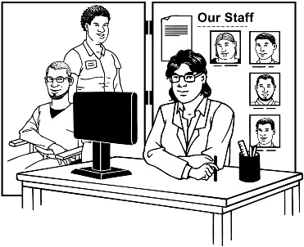All of the support from the Survivor Experiences Service is:

safe

supportive

**confidential.**

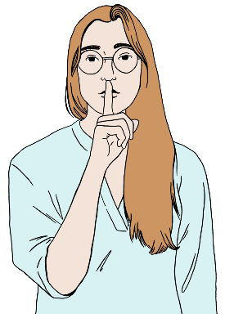

**Confidential** means the people a survivor talks to will not tell other people what the survivor said.



The support from Survivor Experiences Service is free / does not cost you any money.

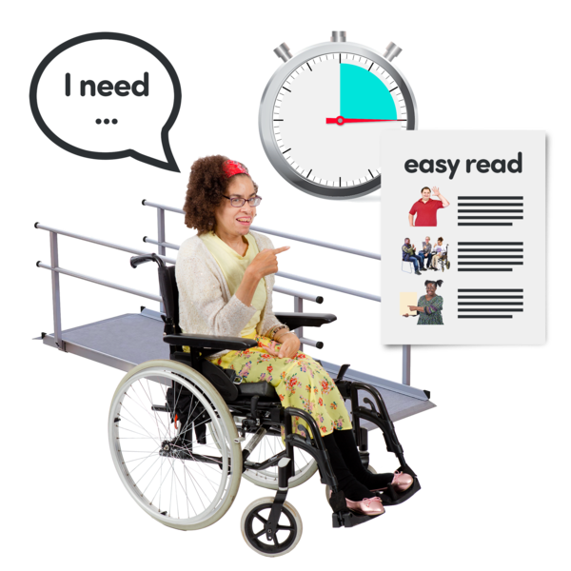

The Survivor Experiences Service will meet any needs you have so you can use the service.

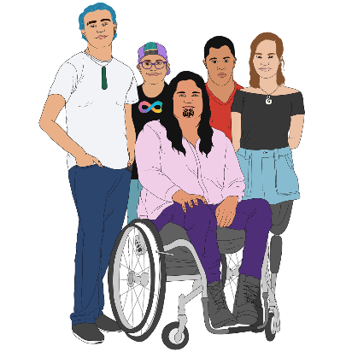This could be needs to do with:

disability

health

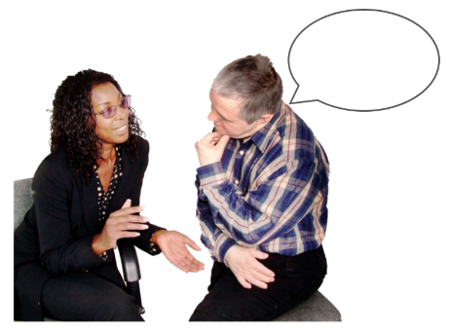communicating

understanding

remembering.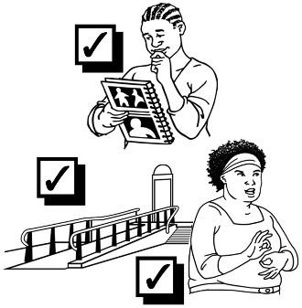

# The sharing experiences service

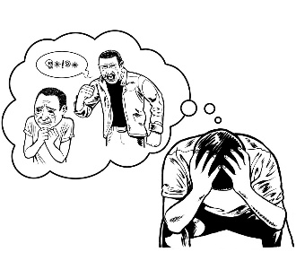

The sharing experiences service is for:

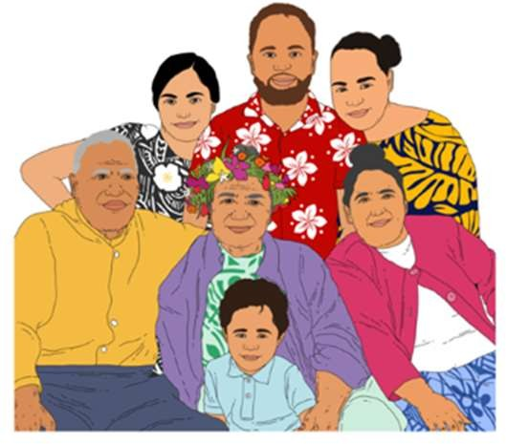survivors

whānau / families of survivors

close supporters of survivors.



You can share your experiences by:

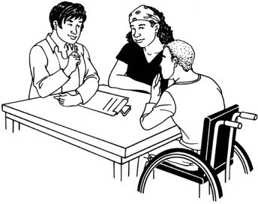writing about them

talking with trained people who will listen.



When you talk with trained people who will listen this is called a **private session**.

You can find out more about private sessions in an Easy Read document called:

**Information about the sharing experiences service**

You can find this Easy Read on our **website**:

**www.survivorexperiences.govt.nz/disabled-survivors**

# The records support service



The records support service is for survivors.



The service will support you to:

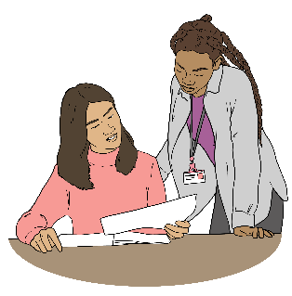find out what records there are about you

get your records

understand your records.

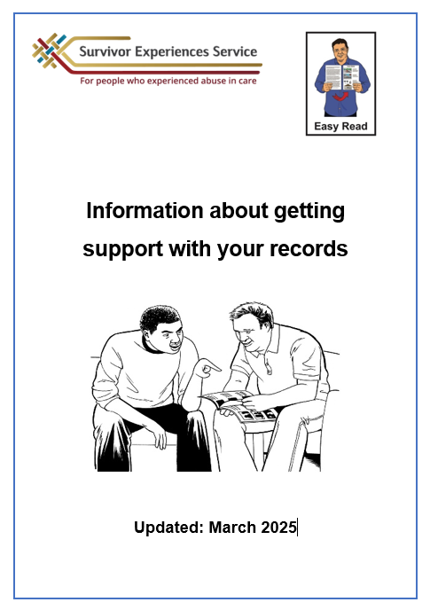

You can find more information about the records support service in the document:

**Information about the records support service**.

You can find this Easy Read on our **website**:

**www.survivorexperiences.govt.nz/disabled-survivors**

# Wellbeing support

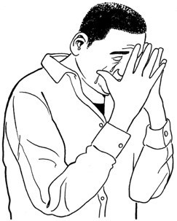

It might be upsetting to talk about your experience with abuse in care.

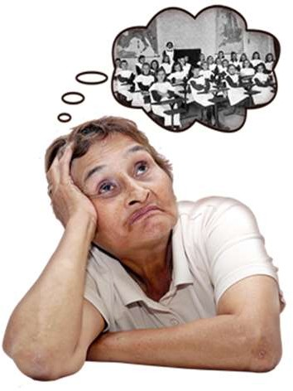

Talking about your abuse might bring back bad memories.

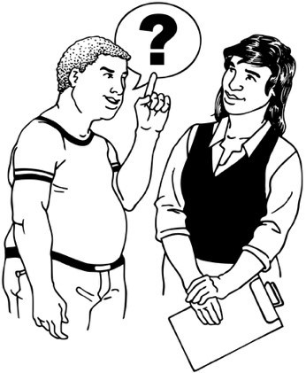You can ask for support at any time.

Asking for support sooner means the service has more time to sort out the right support for you.

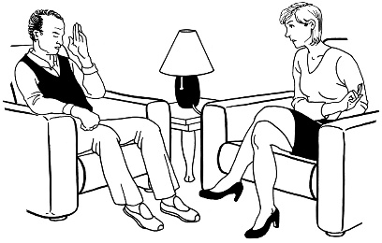

This support is called **wellbeing support**.

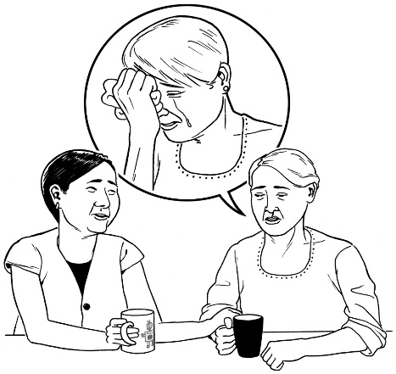**Wellbeing support** means things like:

supporting you to feel okay about yourself

supporting you to take care of yourself

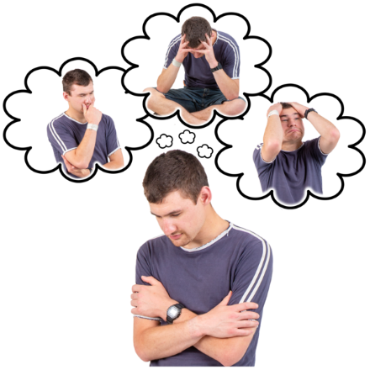supporting you with feelings like being:

* sad
* worried
* angry.

You can find out more about wellbeing support in an Easy Read document called:

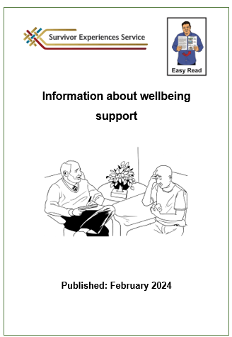**Information about wellbeing support**.

You can read this document at:

**www.survivorexperiences.govt.nz/disabled-survivors**

# How to use the service

If you want to use the Survivor Experiences Service you can:

**phone** on:

**0800 456 090**

**email** at:

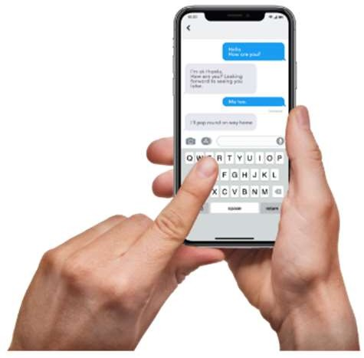**contact@survivorexperiences.govt.nz**

**text** message on:

**8328**

If you find it hard to use the phone the **New Zealand Relay** service is for people who are:

* 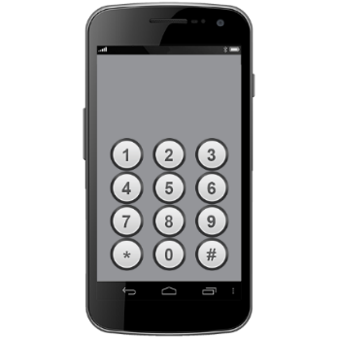Deaf / hard of hearing
* deafblind
* speech impaired / find it hard to talk.

You can find out more about the New Zealand Relay service at:

[**www.nzrelay.co.nz**](http://www.nzrelay.co.nz)

# Where to find more information



You can find more information on our **website**:

**www.survivorexperiences.govt.nz**



This information has been written by the Survivor Experiences Service.

It has been translated into Easy Read by the Make it Easy Kia Māmā Mai service of People First New Zealand Ngā Tāngata Tuatahi.



The ideas in this document are not the ideas of People First New Zealand Ngā Tāngata Tuatahi.



All images used in this Easy Read document are subject to copyright rules and cannot be used without permission.

Make it Easy uses images from:

* Photosymbols
* Change Images
* Huriana Kopeke-Te Aho



* SGC Image Works
* T Wood
* A logo for a school

  Description automatically generatedStudio Rebeko
* Inga Kramer.