
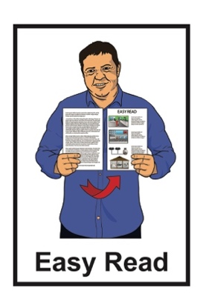

Information for survivors about
other services and helplines
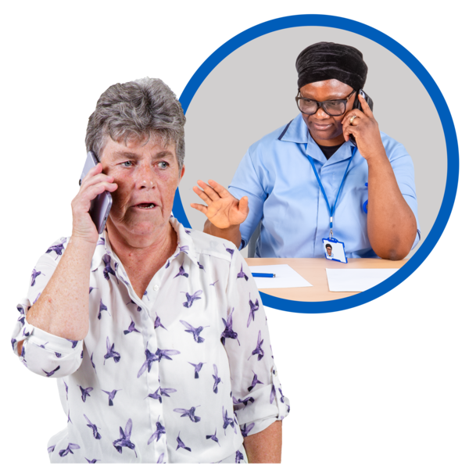

Published: March 2025

Before you start


This is a long document.


It can be hard for some people to read a document this long.

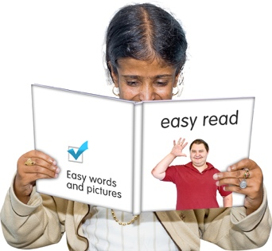
Some things you can do to make it easier are:
- read it a few pages at a time
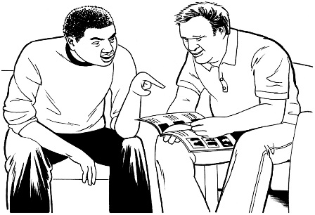
- set aside some quiet time to look at it
- have someone read it with you to support you to understand it.

This document talks about abuse.

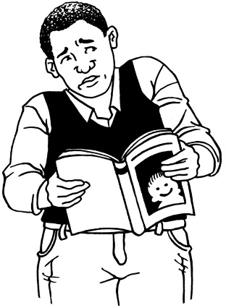

This information may upset some people when they are reading it.

This information is not meant to scare anyone.

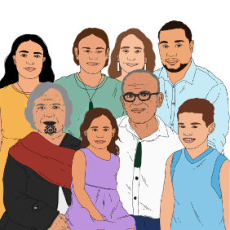
If you are upset after reading this document you can talk to your:

- whānau / family
- friends.

What this document is about

This Easy Read document is from the Survivor Experiences Service.
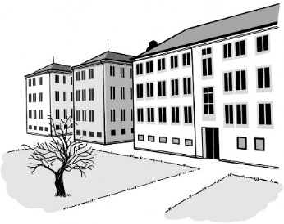

The Survivor Experiences Service is for people who have experienced abuse while in care.
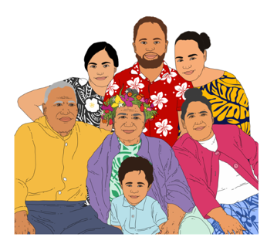

We sometimes call these people survivors.

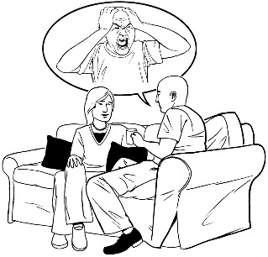
Survivors can use the Survivor Experiences Service to:
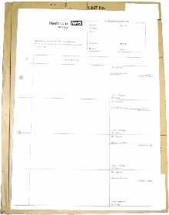
- tell other people what happened to them in care
- get their records from their time in care.
The Survivor Experience Service can give you wellbeing support.

Wellbeing support:
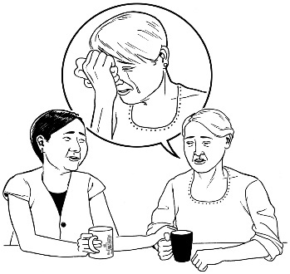
- supports you with the feelings you might have when you talk to the service

- only lasts for a short time.

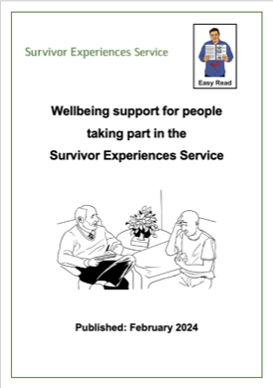
You can find out more about wellbeing support available from the Survivor Experiences Service in the Easy Read document called:

Wellbeing support for people taking part in the Survivor Experiences Service


You can find this Easy Read on our website:

www.survivorexperiences.govt.nz/disabled-survivors
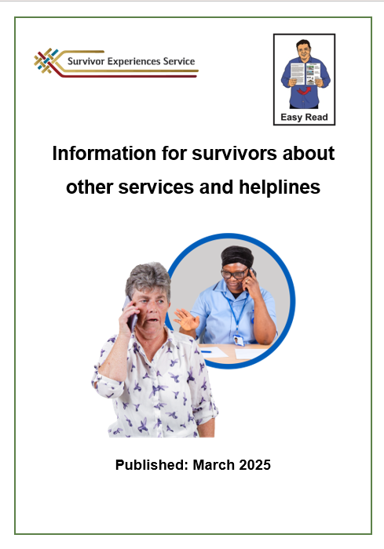
This Easy Read document has information about other services that can support you if you need:
- more support
- different support
- support quickly.


The information in this document is for people who are in Aotearoa New Zealand.

24 / 7 helplines
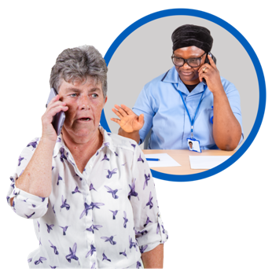

Helplines are services that you can contact for support / advice.



24 / 7 means you can call these helplines any time:
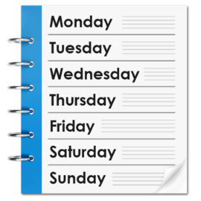
- 24 hours a day
- 7 days a week.


It does not cost money to call these helplines.

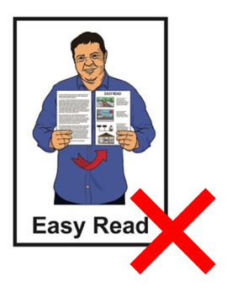
Some of the helplines have websites.

The information on these websites is not in Easy Read.
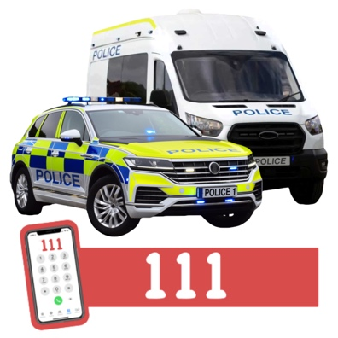
Call the police on 111 if:
- you are in danger
- someone else is in danger.


Depression Helpline

The Depression Helpline can give you support with:

- depression – feeling very sad for a long time
- anxiety – getting really worried about a lot of things.

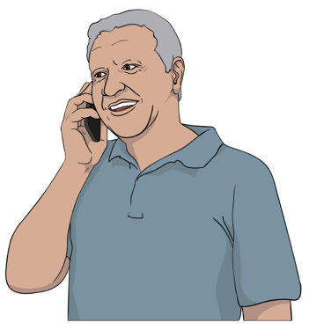
You can:
- phone the Depression Helpline on:
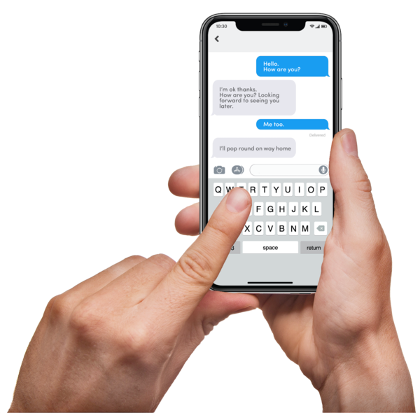
0800 111 757
- text the Depression Helpline on:
4202

The Depression Helpline website is:

www.depression.org.nz


The Depression Helpline website has a lot of information about:
- getting support
- taking care of yourself.

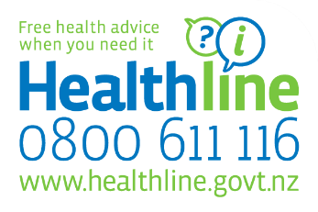
Healthline

You can call Healthline if you are:

- unwell
- hurt
- worried about your health.
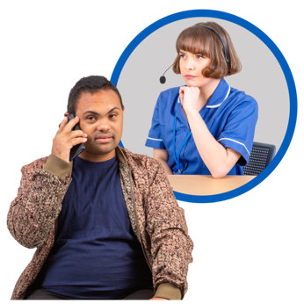

When you call Healthline you will talk to a nurse.


The nurse at Healthline can:
- tell you if you need a doctor / hospital
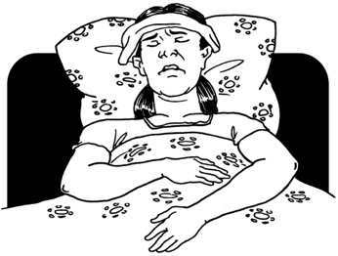
- tell you how to take care of yourself.

You can phone Healthline on:

0800 611 116

The website for Healthline is:

http://tinyurl.com/4zd3m4uj

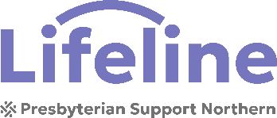
Lifeline


If you are having a hard time you can phone / text Lifeline to get:
- support
- advice
- someone to talk to.
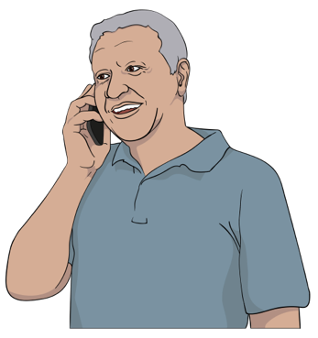

You can call Lifeline on:

0800 543 354

You can text Lifeline on:

4357

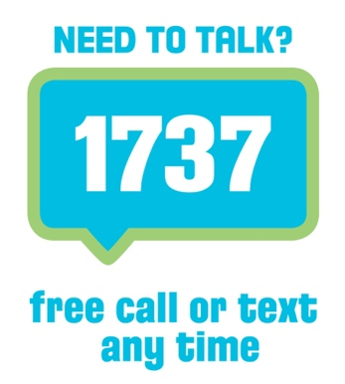
Need to Talk

Need to Talk lets you talk to a counsellor.

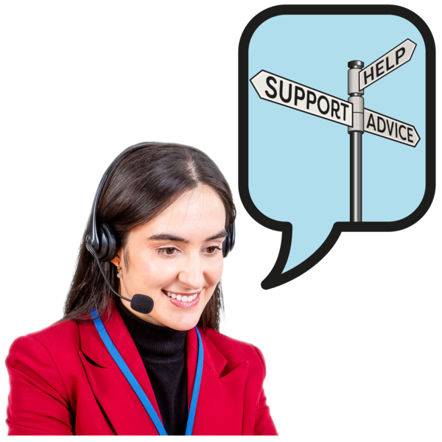
Counsellor means someone who is trained to support people going through a hard time.

You can call Need to Talk if you are feeling:

- stressed
- worried
- sad.


You can phone / text Need to Talk on:

1737

The website for Need to Talk is:

www.1737.org.nz


Safe to Talk

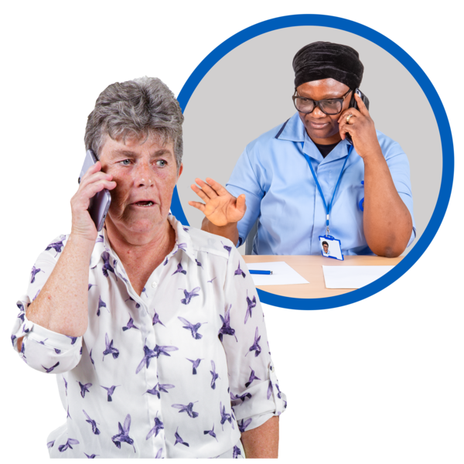
Safe to Talk is for people who have experienced sexual abuse.

You can call Safe to Talk to:
- talk about what has happened to you
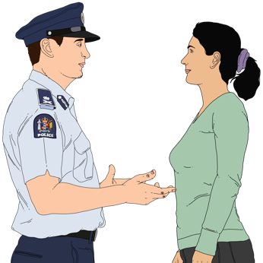
- ask questions about sexual abuse
- get support to tell the police about what has happened
- find out how to get more support.

You can phone Safe to Talk on:

0800 044 334

You can text Safe to Talk on:

4334

The website for Safe to Talk is:

www.safetotalk.nz

Suicide Crisis Helpline

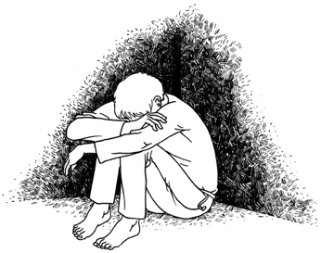
Suicide is when you kill yourself because life feels too hard.

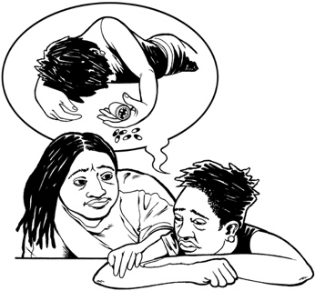
You can call the Suicide Crisis Helpline if:
- you are thinking about suicide
- someone you know is thinking about suicide.

You can phone the Suicide Crisis Helpline on:

0508 828 865

The website for the Suicide Crisis helpline is:

http://tinyurl.com/bdfbrmp8

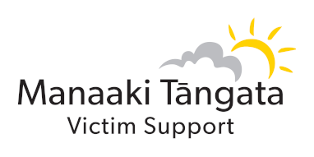
Victim Support

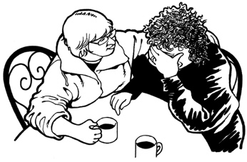
Victim Support can give you support if something bad has happened to you like:
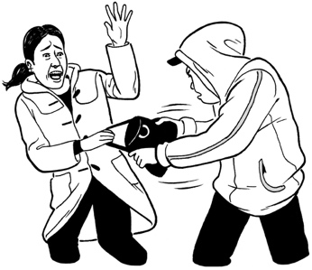
- a crime
- the suicide of someone you know.


They will talk to you to find out what sort of support you need.

You can phone Victim Support on:
0800 842 846

The website for Victim Support is:

www.victimsupport.org.nz

Some other services

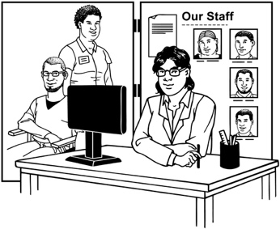
These services can also give you support.


Some of them give support for just 1 thing.

You might only be able to call them at some times.


ACC Sensitive Claims Helpline

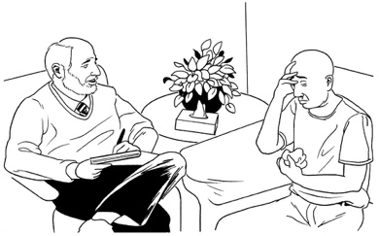
ACC Sensitive Claims supports people who have experienced sexual abuse with:
- counselling
- money if you cannot work because of what has happened.

You can phone ACC Sensitive Claims Helpline to find out more information on:

0800 735 566

The website for ACC Sensitive Claims is:

www.findsupport.co.nz

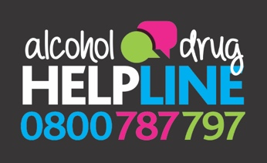
Alcohol and Drug Helpline

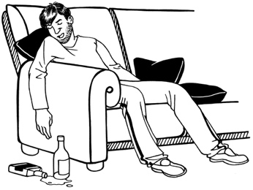
You can call the Alcohol and Drug Helpline if you:
- are worried about how you are using:
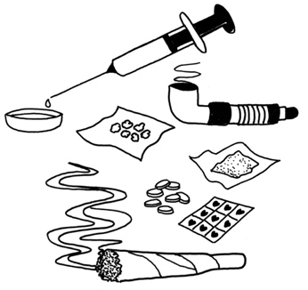
- alcohol
- drugs
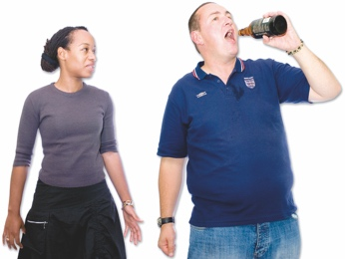
- are worried about someone you know
- want to learn how to keep safe with alcohol / drugs.

You can phone the Alcohol and Drug Helpline on:

0800 787 797

You can text the Alcohol and Drug Helpline on:

8681

The website for the Alcohol and Drug Helpline is:

www.alcoholdrughelp.org.nz


Anxiety Helpline

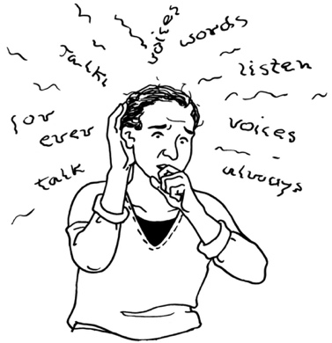
You can call the Anxiety Helpline if you are feeling:
- anxious
- worried
- stressed.

You can phone the Anxiety Helpline on:

0800 269 4389

The website for the Anxiety Helpline is:

www.anxiety.org.nz

Family Services Helpline

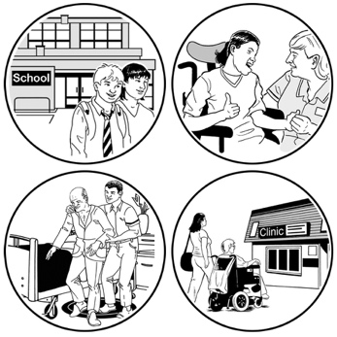
Family Services Helpline has information about support services for lots of different things.


You can search the website to find support where you live.

You can phone the Family Services Helpline on:

0800 211 211

The website for the Family Services Helpline is:

http://tinyurl.com/yjshd3wn


Gambling Helpline


Gambling means paying money for a chance of winning more money.


Gambling can be things like:
- buying a lottery ticket
- betting on a horse race
- playing a pokie machine.


You can call the Gambling Helpline if you:
- are worried about the way you are gambling
- are worried about someone else.


The Gambling Helpline can support you to:
- change how you gamble
- sort out problems gambling has caused for you.

You can phone the Gambling Helpline on:

0800 654 655

You can text the Gambling Helpline on:

8006

The website for the Gambling Helpline is:

www.gamblinghelpline.co.nz


Tautoko Tāne


Tautoko Tāne gives support to men who have experienced sexual abuse.

They can tell you how to find support where you live.

The website for Tautoko Tāne is:

www.tautokotane.nz


OutLine

OutLine gives support to people who are LGBTTQIA+.

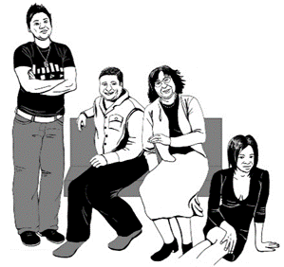
LGBTTQIA+ stands for people who are:

- Lesbian

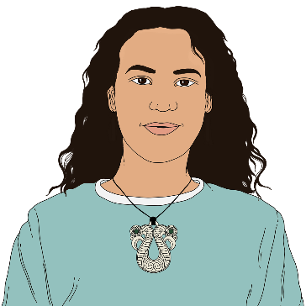
- Gay

- Bisexual

- Transgender
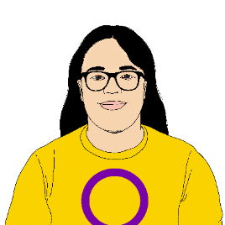
- Takatāpui

- Queer

- Intersex

- Asexual

- + is for other people who fit in similar groups.
You can phone OutLine on:

0800 688 5463

The website for OutLine is:

www.outline.org.nz


Rape Crisis

Rape Crisis gives support to people who have experienced sexual abuse.

You can phone Rape Crisis on:

0800 883 300

Samaritans

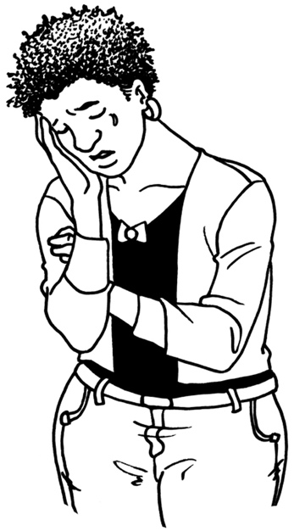
You can call Samaritans if you are feeling:
- lonely
- sad
- worried
- like you want to hurt yourself.

You can phone Samaritans on:

0800 72 66 66

The website for Samaritans is:
www.samaritans.org.nz

Skylight

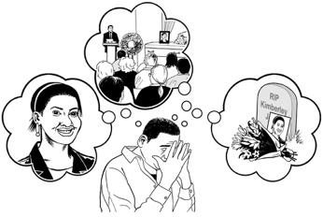
Skylight can give you support if you are going through a hard time like:
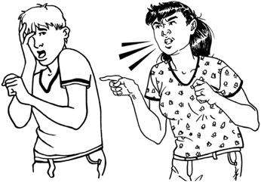
- someone you love has died
- you have been abused
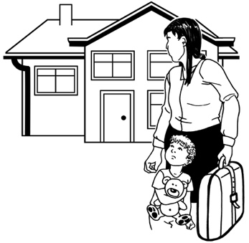
- your marriage / family has broken up
- your children are having a hard time.

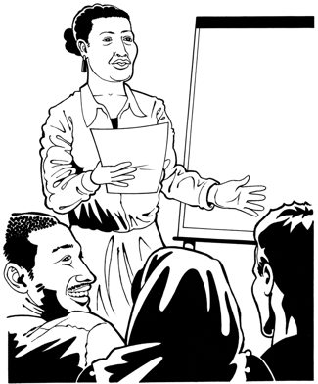
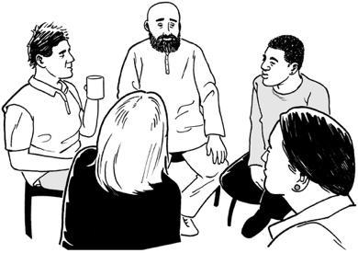
Skylight does:
- counselling
- support groups
- courses.

You can phone Skylight on:

0800 299 100

The website for Skylight is:

www.skylight.org.nz

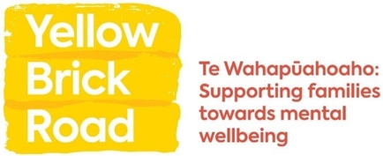
Yellow Brick Road

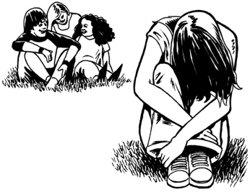
Yellow Brick Road can support you if someone in your whānau / family is having a hard time with their mental health.

You can phone Yellow Brick Road on:

0800 732 825


Youthline

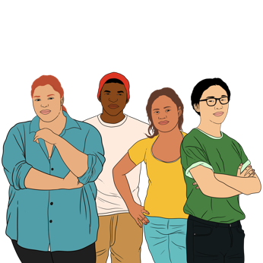
Youthline is for:
- young people aged 12 to 24 years

- people who are supporting young people like:
- parents

- teachers
- friends.

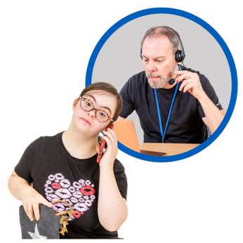
Youthline does:
- counselling
- advice
- mentoring.


Mentoring means working with someone to:
- think about what you want to do
- make a plan.


You can:
- phone Youthline on:


0800 37 66 33
- email Youthline at:

talk@youthline.co.nz

The website for Youthline is:

https://youthline.co.nz/

How to contact the

Survivor Experiences Service

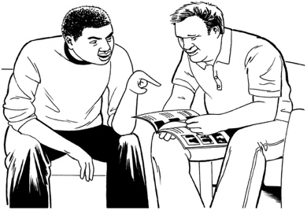
You can talk to the Survivor Experiences Service about the support you need while you are using the service.

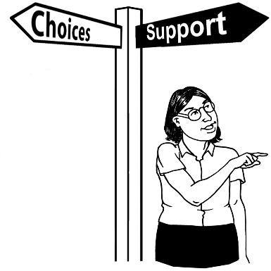
The service can give you:
- emergency support

- long-term support.

Emergency support is when you need support right now.

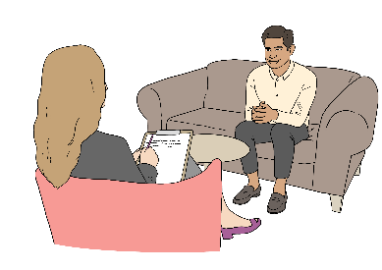
Long-term support is when you need support that keeps going for a long time.
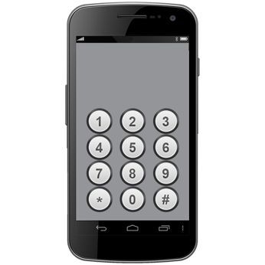
If you are in New Zealand you can phone the service on:

0800 456 090


If you are in Australia you can phone the service on:

1 800 456 032


It does not cost money to call these numbers.


You can phone the service from:

- 8:30 in the morning

to

- 4:30 in the afternoon.


These times are for the New Zealand time zone.

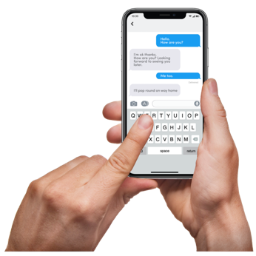
You can text the service on:

8328

You can send an email to:

contact@survivorexperiences.govt.nz

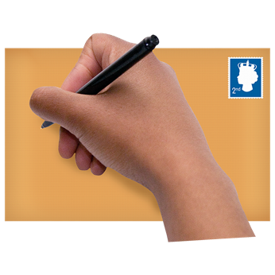
You can write to the service at:

Survivor Experiences Service

PO Box 805

Wellington 6140


If you find it hard to use the phone the New Zealand Relay service is for people who are:

- Deaf / hard of hearing

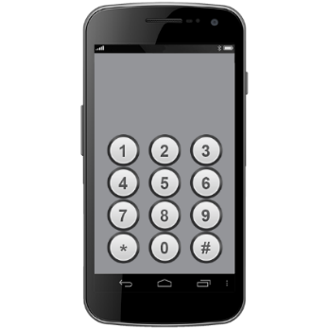
- deafblind

- speech impaired / find it hard to talk.


You can find out more about the New Zealand Relay service at:

www.nzrelay.co.nz

This information has been written by the Survivor Experiences Service.

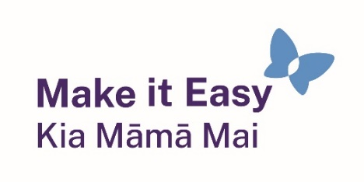
It has been translated into Easy Read by the Make it Easy Kia Māmā Mai service of People First New Zealand Ngā Tāngata Tuatahi.



The ideas in this document are not the ideas of People First New Zealand Ngā Tāngata Tuatahi.

Make it Easy uses images from:


- Changepeople.org


            - Photosymbols.com

- SGC Image Works
- Huriana Kopeke-Te Aho

- T.Wood.

All images used in this Easy Read document are subject to copyright rules and cannot be used without permission.

