# He Mōhiohio mō tō Hui Tūmataiti

**

### Kia ora, Mālō, Talofa, Kia Orana, Bula, hello.

#### Tēnā koe i tō tū mai ki te tuari i tō wheako o te tūkinotanga.

**He mōhiohio mā ngā Whakarauora**

E mōhio ana mātou ki te mana, ki te māia me whai kia tū mai me te kōrero ki a mātou. Ka aro mātou ki a koe, ki te mōhiohio e tuari mai koe ki a mātou i runga i te matatapu, i te whakaute hoki.

Kei ngā mōhiohio e whai ake nei ngā taipitopito mō ngā āhuatanga ka pā ina haere mai koe ki te Survivor Experiences Service | Ratonga Wheako Mōrehu, ā, ka ahatia te mōhiohio ka tukuna e koe.

###### Te Whakarite mō tō Hui Tūmataiti

Te Oranga

Ka tuku mātou i te tautoko me te tohuora utukore ki a koe ina tae mai koe ki te Ratonga. Ka taea e tētahi Kaitautoko Oranga te whakapā atu ki a koe i mua i te hui hei hihira e pai ana koe.

**He hui tūmataiti**

Kua tonoa koe ki tētahi mahinga muna hei tuari i tō wheako o te tūkinotanga i te wā tiaki, ki āu ake kupu.

Ka tūtaki koe i ngā tāngata e toru mai i te ratonga Wheako Mōrehu, ko rātou ko:

* *Tētahi Kaitakawaenga, ka whakarongo ia ki tō kōrero, ka ui atu pea i ētahi pātai hei āwhina i tā mātou māramatanga.*
* *Tētahi Kaiwhakarite Hui, māna, i runga i tō whakaaetanga, e tuhi ētahi tuhipoka, e hopu te hopunga ā-oro; ā,*
* *Tētahi Kaitautoko Oranga e wātea ana ki te tautoko i a koe i mua, i roto, ā muri hoki i tō hui.*

**Te Whakarite mō tō Hui Tūmataiti**

Kei a koe te 60-90 meneti ki te hui tahi ki te Kaitakawaenga.

Hei whakarite mō tō Hui Tūmataiti, he mea āwhina pea te whakaaro ake ki ngā mea e hiahia ana koe ki te whakaputa. He maha ngā mea ka hiahia pea koe ki te whakaputa, nō reira ki te hiahia koe, e pai ana tō tuhi i tērā. Ki te hiahia koe ki te āwhina mō tēnā, waea atu ki te rōpū Whakapā me te Tautoko.

Anei ētahi pātai hei āwhina pea a koe:

* *I pēhea te āhua o tō tamarikitanga?*
* *He aha te take i tukuna koe ki te tiakanga?*
* *He aha ngā āhuatanga i pā atu ki a koe i te wā tiaki?*
* *Nā wai koe i tūkino?*
* *I whāki atu koe ki tētahi mō ngā āhuatanga i te pā atu ki a koe?*
* *He aha ngā pānga o ngā āhuatanga i pā atu ki a koe i te wā tiaki?*
* *He aha ngā ara kua whakahaumarutia kētia koe i te tūkinotanga?*

**Te Rā o te Hui Tūmataiti**

Ka tūtaki tō Kaiwhakarite Hui i a koe i te rā o tō hui tūmataiti. Ka wātea mai tō Kaitautoko Oranga kia kōrero atu koe ki a ia i mua, ā muri hoki i tō hui tūmataiti. Ka wātea hoki mai tēnei tangata i roto i tō hui ki te hiahia koe ki te kōrero atu ki a ia.

I mua i te piri atu a te Kaitakawaenga ki a koe, ka kōrero te Kaiwhakarite Hui ki a koe mō te puka whakaaetanga me te tono i a koe ki te waitohu ake. Ka whakaritea e te puka whakaaetanga kia mōhio koe ki ō tika. Kua whakaurua tētahi tārua o te puka whakaaetanga ki tēnei kete.

Ina rite koe ki te kōrero, ka piri atu te Kaitakawaenga ki a koe, ka whakamōhio atu ki a koe ko wai ia. I mua i te tīmata i te pūrere hopu reo, ka pātai atu te Kaitakawaenga ki a koe mēnā kua rite koe ki te tīmata, me te whakamahara i a koe ka hopungia te hui. Ki te whakatau koe kāore koe i te hiahia kia hopungia te hui, he pai tonu te haere tonu a tō hui.

Kei a koe te tikanga mō te nui ka kōrerotia e koe. I ētahi wā ka ui pea te Kaitakawaenga i ētahi pātai kia tino mārama ia ki ō kōrero. Kia maumahara, ehara i te mea me whakahoki koe, ehara i te mea me kōrero koe mō ngā āhuatanga ki te kore koe e hiahia ana.

**Ā muri i tō hui tūmataiti**

Ā muri i tō hui, he tautoko oranga e wātea ana ki te hiahiatia e koe. Kei reira rātou ki te hiahia koe ki te kōrero ki a rātou, mēnā rānei e hiahia ana koe ki te mōhiohio, ki te tautoko rānei mō te aro ki ō kare-ā-roto ā ngā rangi, ā ngā wiki e tū mai nei.

###### He pēhea te āhua o te tukanga?

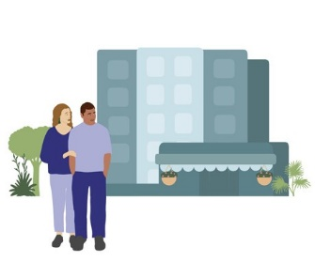

**Nekehanga 1**

Ka tae atu te mōrehu me (t)ōna kaitautoko ki te wāhi

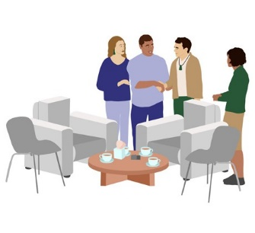

**Nekehanga 2**

Ka mihia te mōrehu me (t)ōna kaitautoko e te Kaiwhakarite Hui me te tangata Oranga.

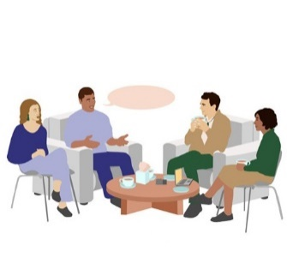

**Nekehanga 3**

Ka kōrerorero te mōrehu rāua ko tana kaitautoko i te hui e tū mai nei tahi ki te Kaiwhakarite Hui me te tangata Oranga.

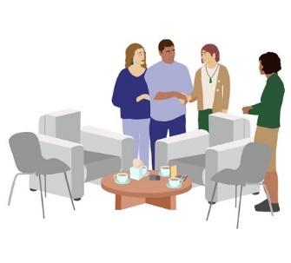

**Nekehanga 4**

Rite ana te mōrehu, ka kuhu mai te Kaitakawaenga, ka tūtaki i te mōrehu me (t)ōna kaitautoko

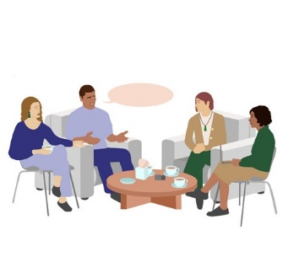

**Nekehanga 5**

Ka kōrero te mōrehu mō tōna wheako ki te Kaitakawaenga mō tōna 90 meneti

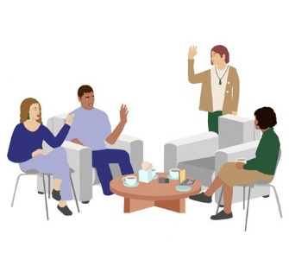

**Nekehanga 6**

Ka puta atu te Kaitakawaenga i te rūma hei te mutunga o te hui tūmataiti

**Nekehanga 7**

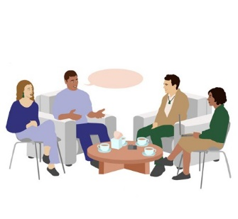

Ka kōrero te Kaiwhakarite Hui rāua ko te tautoko Oranga ki te mōrehu me (t)ōna kaitautoko

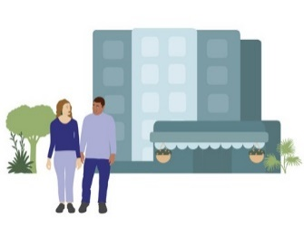

**Nekehanga 8**

Ka wehe atu te mōrehu rāua ko (t)ōna kaitautoko i te wāhi

**He pēhea ō whīra ināianei pea**

Mā te tuari i tō wheako e noho pea koe me te rongo ānō nei kua rangona koe, kua poho kererū pea koe, kua whakamāmāhia, kua iti iho pea te taumaha i runga i a koe. Tērā pea ka rongo hoki koe i te pōuri, i te riri, i te pāpōuri, i tētahi hanumi rānei o ngā tini kare-ā-roto.

Tērā pea he mahere, he rautaki rānei āu ka whakamahia ai hei puta i ngā kare-ā-roto kaha, ā, e āki ana mātou i a koe ki te āta tiaki i a koe anō.

Anei ētahi marohi ka āwhina pea i a koe:

* *me mōhio he mea noa ēnei kare-ā-roto*
* *kōrero atu ki tētahi e whirinakihia ana e koe, ahakoa kāore koe mō te pērā*
* *kia ngākau māhaki koe ki a koe anō*
* *whakapā mai ki a mātou mā te waea ki 0800 456 090*
* *waea atu ki tētahi o ngā ratonga tautoko e rārangihia ana i te pito o tēnei tuhinga*

**He aha te tautoko e wātea ana ā muri i tētahi hui tūmataiti?**

Ka whakapā atu mātou ki a koe i ētahi rā ā muri i tō hui tūmataiti hei hihira e pēhea ana koe, me te ui atu ki a koe mēnā rānei e hiahia ana koe ki te tautoko atu anō.

Mēnā e hiahia ana koe ki te tautoko tāpiri ā muri i tō hui tūmataiti, ka taea e mātou te āwhina ki te whakarite i tērā māu, ahakoa kei a koe kē tētahi kaitohuora, ētahi atu momo tautoko rānei.

Ki te kore ō tautoko haere tonu kē, ka matapaki mātou ki a koe te momo tautoko ka whaitake pea ki a koe. Ka whakarite mātou kia tūtaki tētahi kaitohuora kua whakangungutia, te ngaio tautoko rānei hei hui tahi ki a koe.

###### Ki hea tiki āwhina ai:

Mēnā e āwangawanga ana koe mō tō hauora ā-hinengaro, mō tērā o tētahi atu rānei, ko te wāhi tino pai kia whiwhi āwhina ko tō rata ā-whānau, ko tō kaiwhakarato hauora ā-hinengaro pātata rānei.

Heoi anō, mēnā e mōrearea ana koe, tētahi atu rānei, e whakamōrea ana i ētahi atu rānei, waea wawe ki ngā pirihimana ki 111.

Tērā rānei mēnā e hiahia ana koe ki te kōrero ki tētahi atu:

**LIFELINE:**

0800 543 354

(e wātea ana 24/7)

**SUICIDE CRISIS HELPLINE:**

0508 828 865 (0508 TAUTOKO)

(e wātea ana 24/7)

**YOUTHLINE:**

0800 376 633

**NEED TO TALK?**

Waea utukore, pātuhi rānei ki 1737 (e wātea ana 24/7)

**KIDSLINE:**

0800 543 754

(e wātea ana 24/7)

**WHATSUP:**

0800 942 8787

(1 i te ahiahi ki te 11 i te pō)

**DEPRESSION HELPLINE:**

0800 111 757

(e wātea ana 24/7)

**SAMARITANS:**

0800 726 666

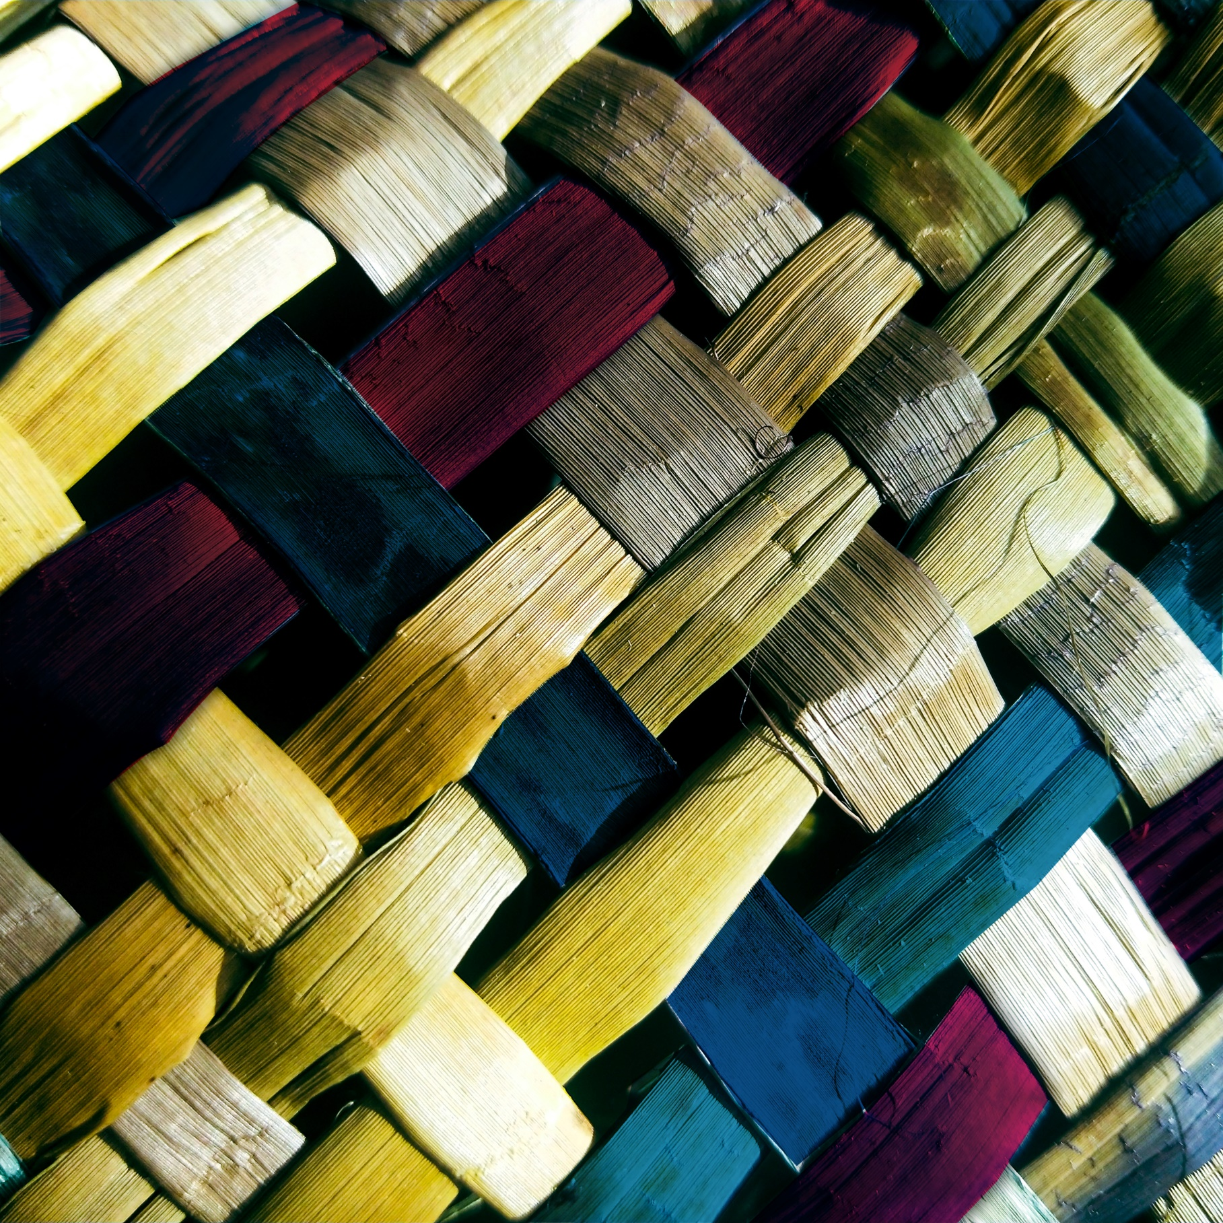

**He Mōhiohio mā te Hunga Tautoko**

### Tēnā koe i tō whakaae ki te tautoko i tētahi mōrehu ki te tuari i tōna wheako ki te Ratonga

**He Mōhiohio mā te Hunga Tautoko**

**He aha te mahi a te kaitautoko?**

Ka tono pea te mōrehu o te tūkinotanga i tētahi tangata, i ētahi tāngata rānei ki te tautoko i a ia ki te tuari i tōna wheako o te tūkinotanga i tētahi hui tūmataiti.

Ka hiahiatia e ngā mōrehu kia tautokona rātou mā ngā ara maha. Hei kaitautoko, ko tō mahi ko te tuku i te momo tautoko e hiahiatia ana e te mōrehu. Ko te ara tino pai ki te pēnei ko te kōrerorero ki a ia mō te momo tautoko e hiahiatia ana e ia i mua, i roto, ā muri hoki i te hui.

**Mēnā he kaitautoko koe ka pēnei pea ngā tono a te mōrehu:**

* *ka āwhina i a ia ki te whakarite mō tōna hui, hei tauira, mā te pānui i ngā mōhiohio, mā te tuhi tuhipoka rānei mō ngā kaupapa ka hiahia pea ia hei kōrerotanga māna*
* *ka tuku i te tautoko kare-ā-roto i taua rā tonu*
* *ka kōrero ki a ia mō ōna piropiro ā ngā rā, ā ngā wiki ā muri i te hui*

**Anei ētahi o ngā mea ka tonoa pea e te mōrehu i te rā o te hui:**

* *te haere i tōna taha ki te wāhi, hoki mai i te wāhi anō hoki*
* *te āwhina i a ia kia noho āhuru, me te noho ki tōna taha i roto i te hui*
* *te whakarite kei a ia ngā mea katoa e hiahiatia ana*
* *te tono i te paramanawa mēnā e hiahiatia ana*
* *te tatari i waho i te rūma tae noa atu kia mutu te hui*

Mēnā e tautoko ana koe i tētahi e noho ana i te whare herehere i tēnei wā, me tū koe hei manuhiri i whakaaetia kia āhei ai tō uru atu ki te whare herehere.

**He aha ngā mea me KAUA rawa e mahia e te kaitautoko?**

I roto i te hui tūmataiti me kaua te tangata tautoko e kōrero mō te mōrehu.

I pēnei ai nā te mea ko te take o te hui tūmataiti kia rongo te Kaitakawaenga tōtika i ngā mōrehu mō ōna wheako.

He mea nui te maumahara ehara te mahi a te kaitautoko i te mahi i te mahi ki ō whakaaro ko te painga atu mō te mōrehu, te whakatau take mōna rānei.

Mēnā he mōrehu hoki koe, he kaiwhakaatu i te tūkinotanga, ā, e hiahia ana koe ki te tuari i tō wheako ki te Ratonga ka taea te rēhita mā te waea mai ki 0800 456 090.

**Tō oranga**

I te rā o te hui tūmataiti ka wātea mai tētahi tangata Oranga ki a koe kia kōrero atu koe ki a ia mēnā e hiahiatia ana. Tērā pea he hui o te wheako o te mōrehu kāore anō kia

rangona e koe, he mea whakakohuki rānei te whakarongo atu. Ka taea e te tangata Oranga te āwhina i a koe ki te puta i ēnei kare-ā-roto.

**Te Matatapu**

He matatapu ngā hui tūmataiti māna ka whakaae te tangata e tautokona ana e koe kia tukuna tūmatanuitia te mōhiohio. I mua i te hui tūmataiti, ka tono te Kaiwhakarite Hui ki a koe ki te whakaoti i tētahi puka e tauākī ana kua mārama tēnei i a koe.

Ka tono hoki ia ki a koe ki te whakaū i tō whakaae kia noho matatapu ngā kōrero katoa i whakapuakina i te hui tūmataiti, ā, kāore koe e matapaki atu ki tētahi atu.

Kei roto i tēnei ko ērā atu tāngata i tō ao, tae atu ki; tō whānau, ngā kaimahi tautoko, ngā āpiha o Ara Poutama Aotearoa, me ngā kaitukumahi. Ki te kore koe e whakaae, kāore koe e whakaaetia kia noho tonu i te hui.

**Ngā Kaikawe Kōrero e Haere ana ki ngā Hui Tūmataiti**

He ara wātea ngā hui tūmataiti kei te Ratonga Wheako Mōrehu kia kōrero ngā mōrehu i runga i te matatapu mō ō rātou wheako ki tētahi Kaitakawaenga. I runga i te āhuatanga tūmataiti o ēnei hui takitahi, i runga hoki i te hiahia kia āhuru ngā mōrehu ki te kōrero tuwhera, kōrero pono mō tō rātou wheako, kāore te Ratonga i te whakaae kia tae mai te hunga pāpāho.

He tino mārō tā te Ratonga whai i te hiahia ki te whakahaumaru i te tūmataiti, i te matatapu hoki o tēnei mōhiohio, ā, he kaupapa here mārama, he pūnaha whakahaere mōhiohio ōna kia pēnei ai. Mēnā he kaikawe kōrero te mahi a tō kaitautoko, e whakaaetia ana kia tae atu hei tō kaitautoko, engari kaua ki te pūrongo mō te hui, te hopu rānei i tēnā.

**What is the difference between a support person and an advocate?**

He aha te rerekētanga o te kaitautoko me te kaitaunaki?

Ko te kaitaunaki ko tētahi tangata kua tukuna te whakaaetanga ki a ia e tētahi mōrehu hei kōrero mōna, hei tauira, hei kōrero i tana kōrero mōna. Ko ngā kaitaunaki ko ngā whanaunga, ko ngā hoa, ko ngā tāngata nō ngā whakahaere rānei pea. Mēnā e hiahia ana te tangata e tautokona ana e koe kia tū koe hei kaitaunaki me kōrero mai kōrua ko te mōrehu ki a mātou e pā ana ki tēnei i mua i te rā o te hui.

**He aha te rerekētanga o te kaitautoko me te kaiāwhina mō te hui?**

Ko te kaiāwhina mō te hui ko tētahi tangata e āhei ana ki te āwhina i te mōrehu ki te mārama ki ngā mōhiohio, ki te whakatau take mō ngā mahi ka mahia e ia. Heoi anō, ehara ia i te kaitaunaki, ā, tē taea e ia te kōrero mō te mōrehu. He nui te wheako o ngā kaiāwhina o te hui mō te tautoko i ngā tāngata whai hauātanga ako, he kanorau ā-roro rānei rātou. Mēnā he uaua ki te tangata e tautokona ana e koe te mārama ki te mōhiohio mō te Ratonga, kei te hiahia ia ki te āwhina tāpiri rānei hei whakatau mēnā rānei me whai wāhi mai, tēnā whakapā mai ki a mātou i mua i te rā o te hui.

**Whakapā**

Hei rapu i ētahi atu mōhiohio mō te ratonga, hei rēhita rānei, tēnā, waea, pātuhi, īmēra rānei ki tō mātou Pokapū Whakapā.

Waea Utukore (8:30 i te ata - 4:30 i te ahiahi i Aotearoa):



**NZ | 0800 456 090**

**AUS | 1800 456 032**

(Waea utukore mai i Ahitereiria)

Pātuhi: 8328

Īmēra:

[contact@survivorexperiences.govt.nz](mailto:contact@survivorexperiences.govt.nz)



Paetukutuku:

<https://survivorexperiences.govt.nz>

Tuhi mai ki a mātou:



Survivor Experiences Service | Ratonga Wheako Mōrehu

PO Box 805

Wellington 6140